**17.fetchuserapp**

**Step-1:Created a react app with name fetchuserapp**

**>npx create-react-app fetchuserapp**

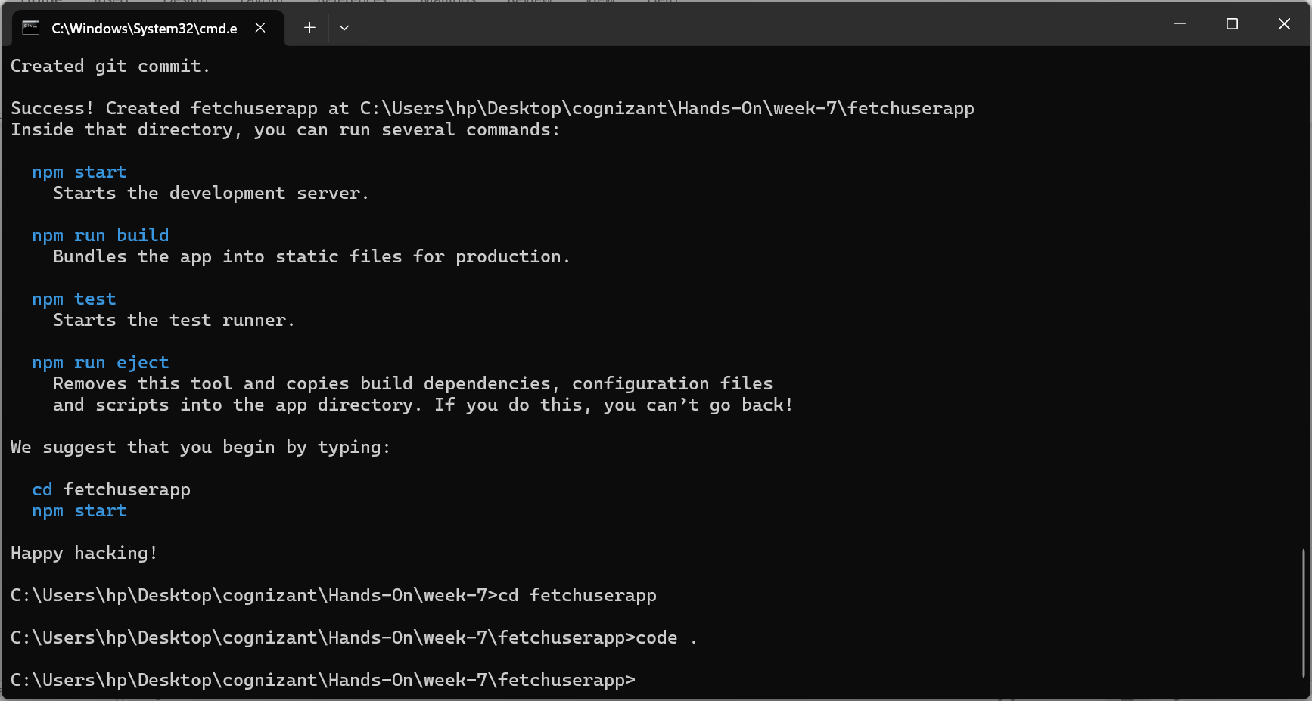

**Step-2:**

**Created a class component Getuser which fetches from link:** <https://api.randomuser.me/> **and using componentDidmount() fetched and displayed the content**

**GetUser.js**

import React, { Component } from 'react';

export class Getuser extends Component {

  constructor() {

    super();

    this.state = {

      person: null,

      loading: true

    };

  }

  async componentDidMount() {

    const url = "https://api.randomuser.me/";

    const response = await fetch(url);

    const data = await response.json();

    this.setState({ person: data.results[0], loading: false });

    console.log(data.results[0]);

  }

  render() {

    const { person, loading } = this.state;

    if (loading) {

      return <h2>Loading user data...</h2>;

    }

    return (

      <div style={{ textAlign: 'center'}}>

        <strong>{person.name.title}{" "}</strong>

        <strong>{person.name.first}</strong>

        <br></br>

        <img src={person.picture.large} alt="User"/>

      </div>

    );

  }

}

**App.js**

import React from 'react';

import { Getuser } from './GetUser';

function App() {

  return (

    <div>

      <Getuser />

    </div>

  );

}

export default App;

**Step-3:**

**Output:**

